**Customers Viewing Previous Orders**

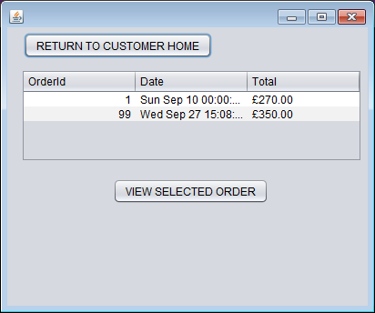

**Customers Viewing Previous Order Lines**

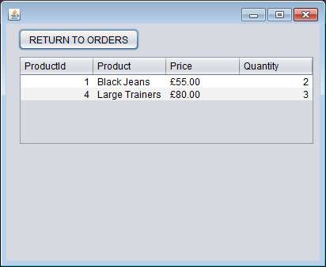

**Staff Viewing Previous Orders**

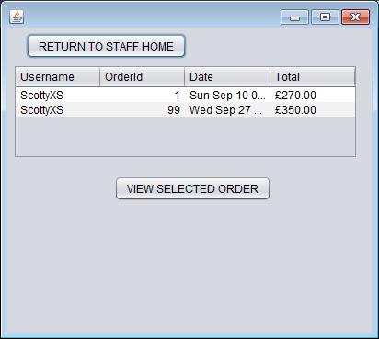

**Staff Viewing Previous Order Lines**

